## Assignment Day 25

Output :-

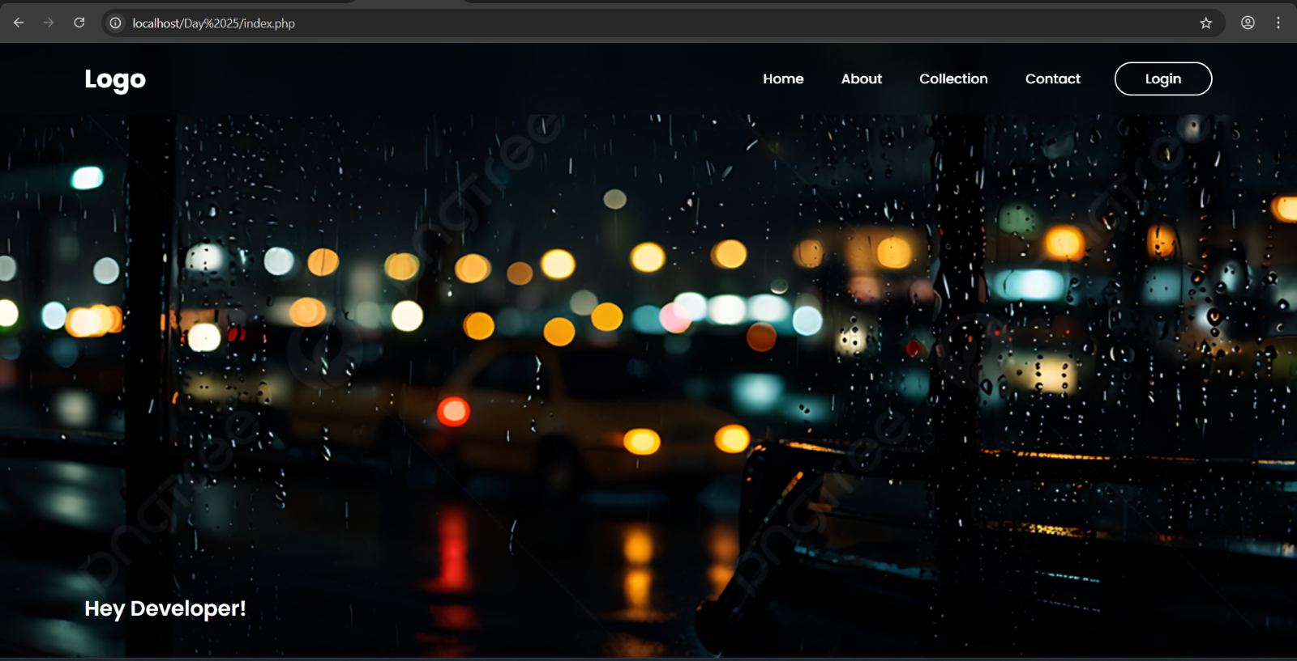

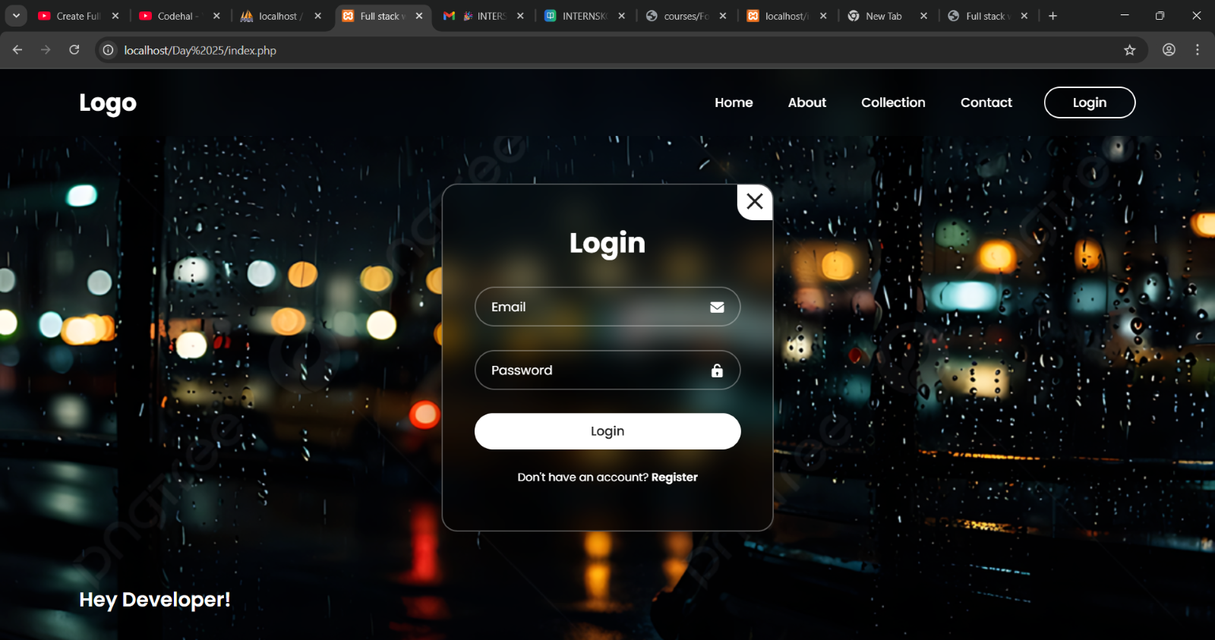

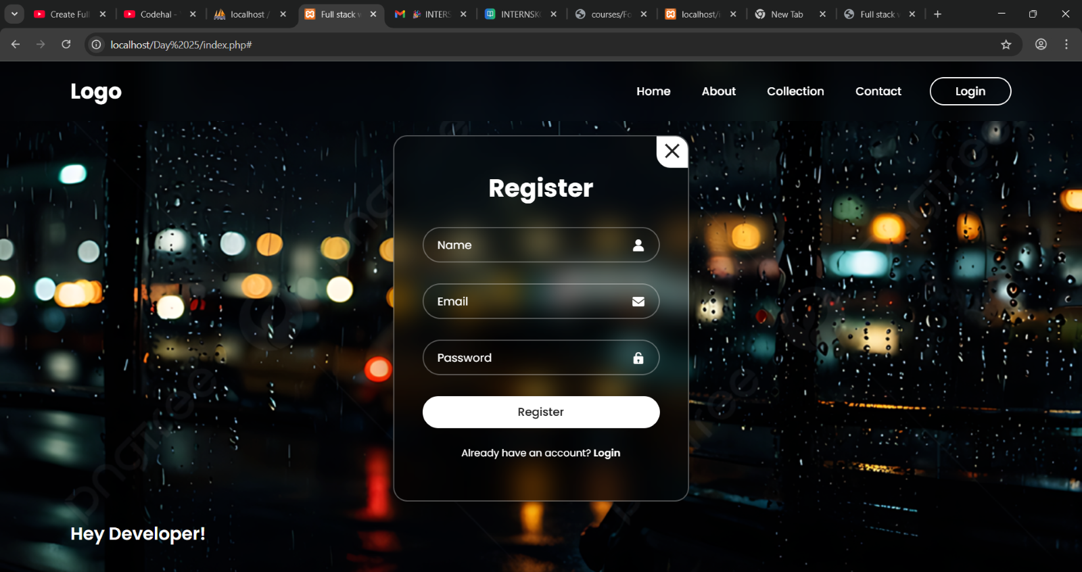

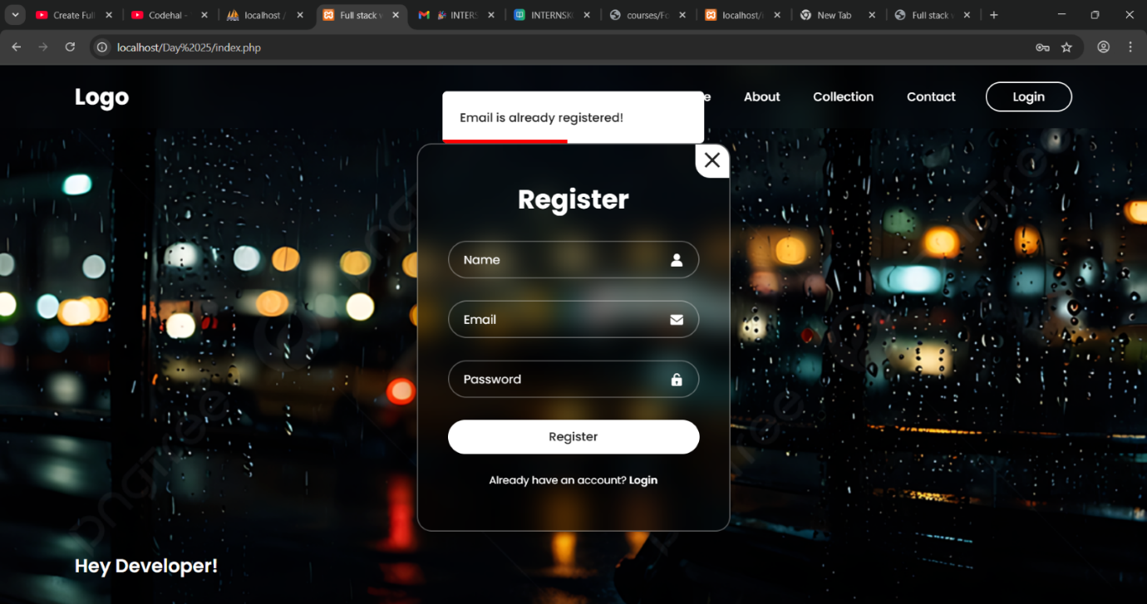

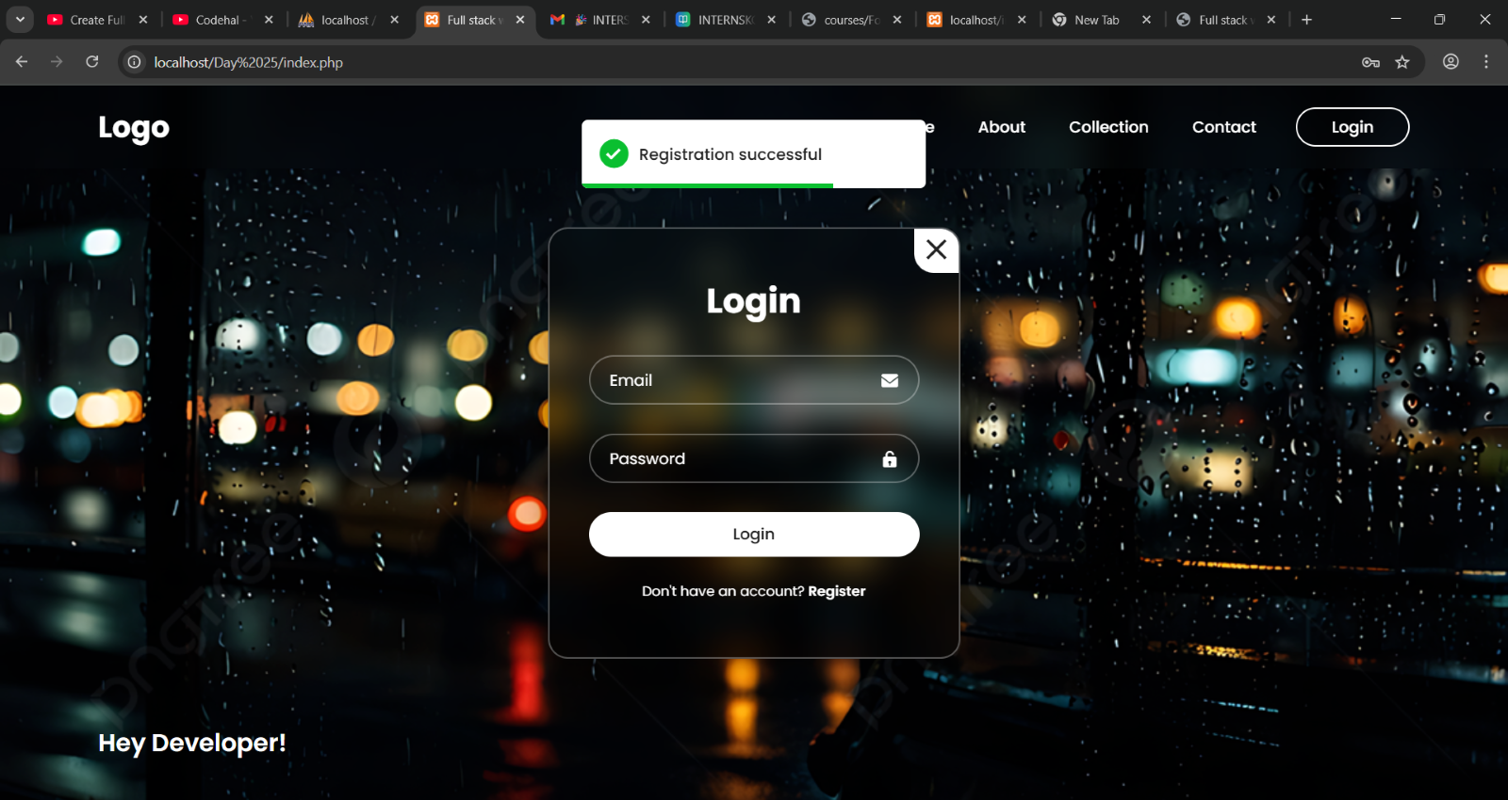

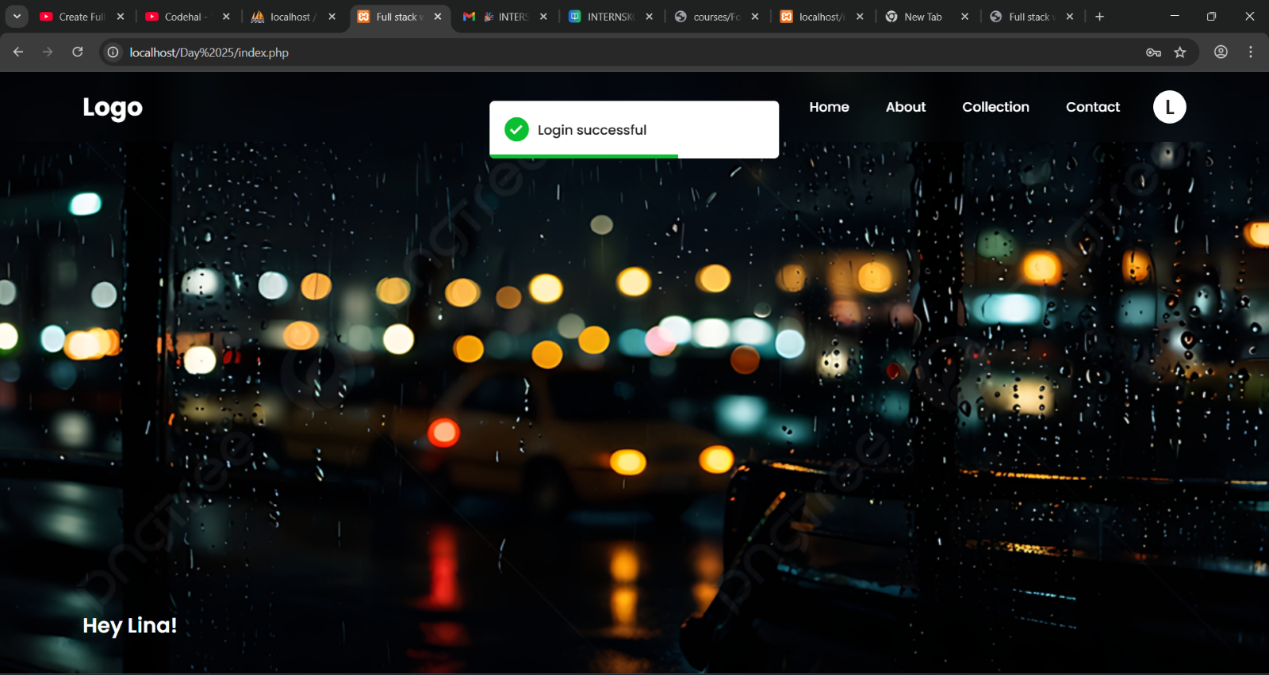

**user_db.sql**

CREATE DATABASE IF NOT EXISTS user_db;

USE user_db;

CREATE TABLE IF NOT EXISTS users (

    id INT AUTO_INCREMENT PRIMARY KEY,

    name VARCHAR(100) NOT NULL,

    email VARCHAR(100) NOT NULL UNIQUE,

    password VARCHAR(255) NOT NULL

);

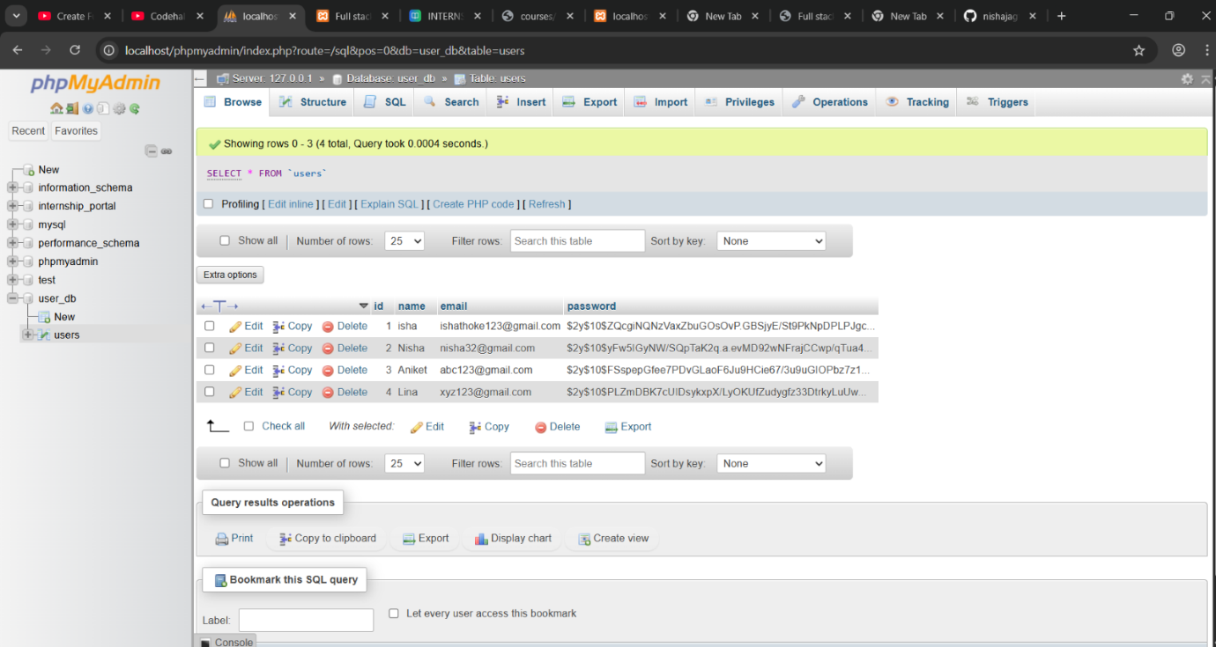

In this task, a full-stack user authentication system using PHP, MySQL, HTML, CSS, and XAMPP. It includes:

* A registration form to create new user accounts (with password hashing and email uniqueness check).
* A login form to authenticate users.
* Session-based alerts to show success or error messages after registration and login.
* A logout option to end the session.
* Data is stored in a MySQL database via config.php connection.

The project also uses modal popups for forms and displays alerts using $_SESSION.